1. **Entities – Relationship Diagram**

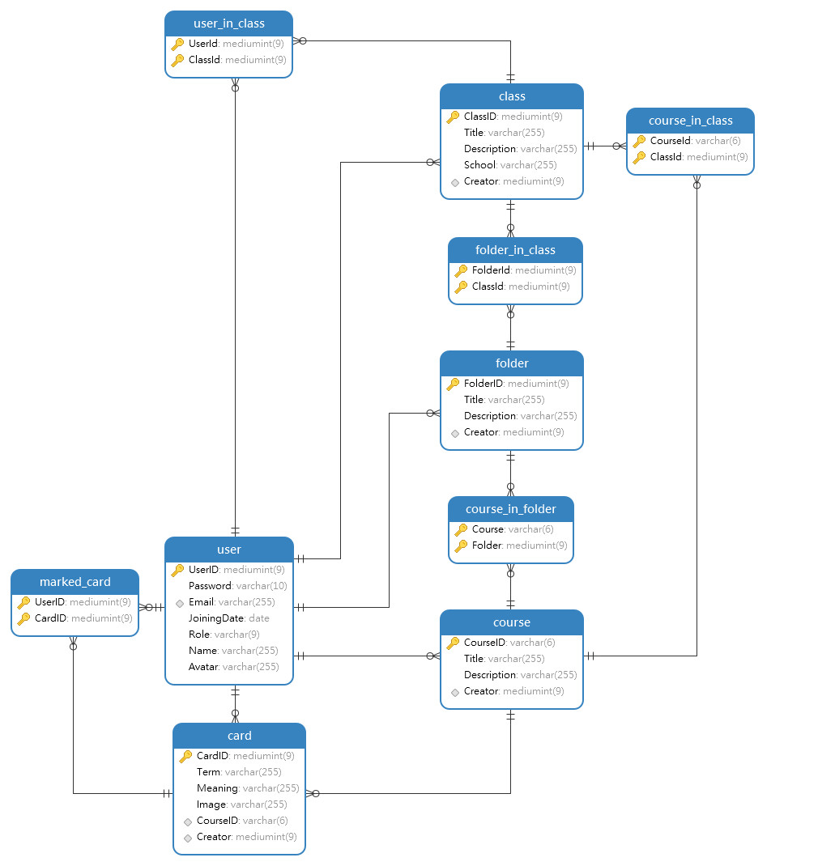

1. **Data Dictionary** 
   1. **Table: user**

|  |  |  |  |  |
| --- | --- | --- | --- | --- |
| Field Name | Data Type | Field length | Constraint | Description |
| UserID | Mediumint | 9 | Not null  Primary key | User id  Auto generated |
| Password | Varchar | 10 | Not null | Login password for user |
| Email | Varchar | 255 | Not null | Email address of user  Unique |
| JoiningDate | Date |  | Not null | The date when user registered successfully |
| Role | Varchar | 9 | Not null | Role of user |
| Name | Varchar | 255 | Not null | Name of user |
| Avatar | Varchar | 255 | Not null | User’s avatar |

* 1. **Table: card**

|  |  |  |  |  |
| --- | --- | --- | --- | --- |
| Field Name | Data Type | Field length | Constraint | Description |
| CardID | Mediumint | 9 | Not null  Primary key | Card id  Auto generated |
| Term | Varchar | 255 | Not null | Term of the card |
| Meaning | Varchar | 255 | Not null | Meaning of the term |
| Image | Varchar | 255 |  | Image link |
| CourseID | Varchar | 6 | Not null | Id of course that contains this card |
| Creator | Mediumint | 9 | Not null | Id of person creating this card |

* 1. **Table: course**

|  |  |  |  |  |
| --- | --- | --- | --- | --- |
| Field Name | Data Type | Field length | Constraint | Description |
| CourseID | Varchar | 6 | Not null  Primary key | Course id  Auto generated |
| Title | Varchar | 255 | Not null | Title of course |
| Description | Varchar | 255 |  | Description of course |
| Creator | Mediumint | 9 | Not null | Id of who creates this course |

* 1. **Table: folder**

|  |  |  |  |  |
| --- | --- | --- | --- | --- |
| Field Name | Data Type | Field length | Constraint | Description |
| FolderID | Mediumint | 9 | Not null  Primary key | Folder id  Auto generated |
| Title | Varchar | 255 | Not null | Title of folder |
| Description | Varchar | 255 |  | Description of folder |
| Creator | Mediumint | 9 | Not null | Id of who creates this folder |

* 1. **Table: course_in_folder**

|  |  |  |  |  |
| --- | --- | --- | --- | --- |
| Field Name | Data Type | Field length | Constraint | Description |
| CourseID | Varchar | 6 | Not null  Primary key | Course’s id |
| FolderID | Mediumint | 9 | Not null  Primary key | Folder’s id |

* 1. **Table: class**

|  |  |  |  |  |
| --- | --- | --- | --- | --- |
| Field Name | Data Type | Field length | Constraint | Description |
| ClassID | Mediumint | 9 | Not null  Primary key | Class id  Auto generated |
| Title | Varchar | 255 | Not null | Title of class |
| Description | Varchar | 255 |  | Description of class |
| School | Varchar | 255 |  | School name |
| Creator | Mediumint | 9 | Not null | Id of who creates this class |

* 1. **Table: marked_card**

|  |  |  |  |  |
| --- | --- | --- | --- | --- |
| Field Name | Data Type | Field length | Constraint | Description |
| UserID | Mediumint | 9 | Not null  Primary key | ID of user |
| CardID | Mediumint | 9 | Not null  Primary key | ID of card being marked |

* 1. **Table: course_in_class**

|  |  |  |  |  |
| --- | --- | --- | --- | --- |
| Field Name | Data Type | Field length | Constraint | Description |
| CourseID | Varchar | 6 | Not null  Primary key | ID of course |
| FolderID | Mediumint | 9 | Not null  Primary key | ID of folder including the course |

* 1. **Table: folder_in_class**

|  |  |  |  |  |
| --- | --- | --- | --- | --- |
| Field Name | Data Type | Field length | Constraint | Description |
| FolderID | Mediumint | 9 | Not null  Primary key | ID of folder |
| ClassID | Mediumint | 9 | Not null  Primary key | ID of folder including the folder |